27th February 2018.

To: Each Member of the Joint Policing Committee.

Re: Meeting of the Joint Policing Committee

Dear Member,

I wish to inform you that the next meeting of the Joint Policing Committee will take place in the Council Chamber, Aras an Chontae, Great Water Street, Longford, on Monday, 5th March 2018 at 3.00 p.m. to transact business, as set out on the Agenda hereunder.

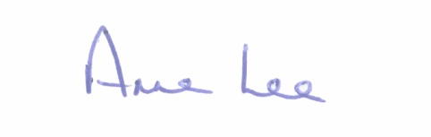
Yours sincerely,

___________________
Anne Lee,
Administrative Officer.
AGENDA

1. Confirmation of Minutes of Joint Policing Committee meeting held on the
4th December 2017 - enclosed.

2. Matters arising.
3. Garda Report.
4. Local Authority Report.
5. Update on CCTV.
6. Update on Longford Joint Action Plan.
7. Consideration of Longford JPC 2017 Annual Report – to follow.
8. A.O.B.
9. Date of next meeting.

